|  |  |
| --- | --- |
| COLOUR_LOGO Aug 2010 | **Year 12 *ATAR* Physics Unit 3** **2017**  ***TEST 5 Electromagnetism 2 5.0%***  **NAME: ………………………………………………….**  Data: See Data Sheet  Approx. marks shown.  ***(55 marks)*** |

When calculating numerical answers, show your working or reasoning clearly. Give final answers to **three** significant figures and include appropriate units where applicable.

When estimating numerical answers, show your working or reasoning clearly. Give final answers to a maximum of **two** significant figures and include appropriate units where applicable.

|  |  |
| --- | --- |
| 1. By moving a permanent magnet sideways perpendicularly past a wire, a voltage will be generated between the ends of that wire. 2. Describe what factors determine the polarity and magnitude of this voltage. [4]   ……………………………………………………  …………………………………………..……….  ……………………………………………………  …………………………………………..……….  …………………………………………………… | https://sub.allaboutcircuits.com/images/quiz/00255x01.png |

……………………………………………………

…………………………………………………………………………………………………….

…………………………………………………………………………………………………….

…………………………………………………………………………………………………….

…………………………………………………………………………………………………….

…………………………………………………………………………………………………….

…………………………………………………………………………………………………….

1. In the diagram given, when moving the permanent magnet sideways to the ***left***, the red probe attached to the positive jack of the voltmeter produces a positive reading.

Which pole of the magnet is closest to the wire? [1]

…………………………………………………………………………………………………….

1. In each of the diagrams below clearly show the direction of the induced current through the resistor *XY* when the magnet moves relative to the coil as shown. [2]

|  |  |
| --- | --- |
| *Y*  *X* | *Y*  *X* |

|  |  |
| --- | --- |
| 1. Consider the coil of wire located the magnetic field shown.   (a) How many turns of wire must the coil have in order to induce a voltage of 10.5 volts when exposed to a magnetic flux decreasing at a rate of 0.0075 Wb s–1? [3] |  |

1. On the diagram above clearly show the direction of the induced current in the loop. [1]
2. Electromechanical watt-hour meters use an aluminium disk that is spun by an electric motor. To generate a constant “drag” on the disk necessary to limit its rotational speed, a strong magnet is placed in such a way that its lines of magnetic flux pass perpendicularly through the disk’s thickness:

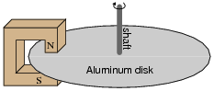

1. Using the laws of induction explain the phenomenon behind this magnetic “drag” mechanism. [5]

…………………………………………………………………………………………………….

…………………………………………………………………………………………………….

…………………………………………………………………………………………………….

…………………………………………………………………………………………………….

…………………………………………………………………………………………………….

…………………………………………………………………………………………………….

…………………………………………………………………………………………………….

…………………………………………………………………………………………………….

…………………………………………………………………………………………………….

…………………………………………………………………………………………………….

1. Explain how the permanent magnet assembly should be re-positioned so that it provides *less* drag on the disk for the same rotational speed. The poles of the magnet remain completely over the disk. [2]

…………………………………………………………………………………………………….

…………………………………………………………………………………………………….

…………………………………………………………………………………………………….

…………………………………………………………………………………………………….

1. The diagram below shows a conducting bar PQ moving with constant speed, 2.00 m s–1, along two parallel conducting rails 3.00 m apart. The ends of the bar touch the rails. The rails are connected by a 10.0 Ω resistor, as shown. The resistance of the bar and rails is negligible.

There is a uniform magnetic field of magnitude 0.50 T perpendicular to the bar and the rails. This field is directed into the page.

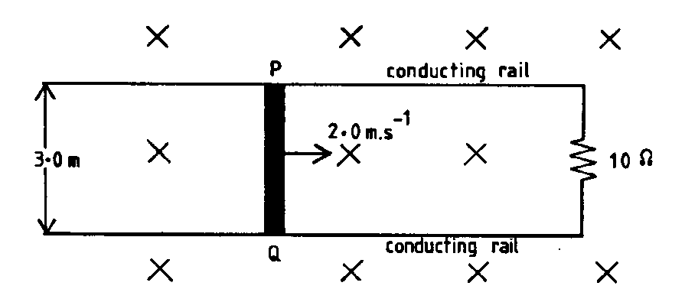

(a) What is the magnitude of the EMF induced in the bar? Show your working. [2]

(b) What is the magnitude of the force required to keep the bar moving? Show your working. [2]

1. The rails are frictionless and there is good electrical contact between the bar and the rails. Why is it necessary to apply a force to keep the bar moving at a constant speed?

[2]

…………………………………………………………………………………………………….

…………………………………………………………………………………………………….

…………………………………………………………………………………………………….

…………………………………………………………………………………………………….

…………………………………………………………………………………………………….

1. Two coils A and B are placed closed together, as shown below. P and Q are soft iron cores.

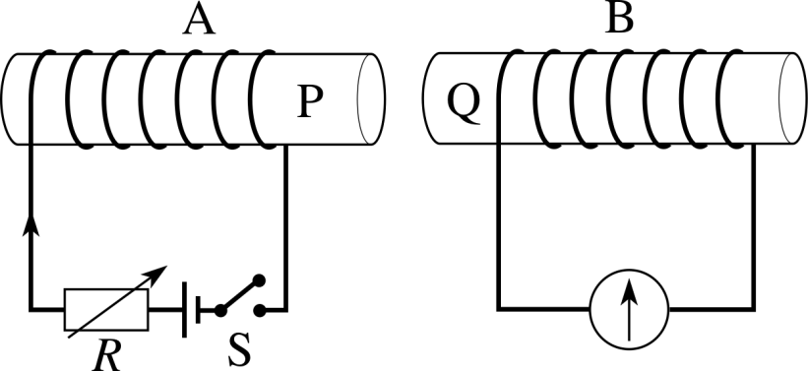

1. Show the direction of the current induced in coil B when the switch in coil A is closed.

[1]

1. The graph below shows how the magnet field strength changes in coil A when the switch closes.

B

(mT)

t (μs)

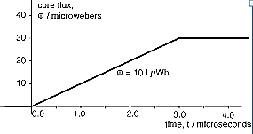

Assume that all of the magnetic flux from coil A passes through coil B which has an area of 5.0 cm2.

1. Calculate the emf induced in coil B. [5]
2. On the axes below draw the graph of the emf calculated in (i). [3]

[t = 0 s when the switch is closed.]

1. (a) A generator has a rectangular coil of side 15 cm by 12 cm that lies perpendicular to a magnetic field of flux density 4.0 T. What is the magnetic flux passing though the coil? [2]
2. The coil, consisting of 20 turns of wire, is rotated and generates a peak emf of 63.5 V. Calculate the frequency with which it is being rotated. [2]
3. The coil of the above generator is shown below. In Figure 7A the coil is connected to slip rings. In Figure 7B the coil is connected to a split commutator.

|  |  |
| --- | --- |
| current    **Fig 7A** | current    **Fig 7B** |

1. On Figure 7A ***clearly*** show the direction of rotation of the coil that induces the direction of the current shown on the diagram. [1]
2. On the axes below draw the graph of the emf induced by during one rotation of each of the generators above. Assume that time *t* = 0 s when the coil is located in the position shown in Figure 7A and in Figure 7B.

Also indicate ***clearly*** on the graph the time when the plane of the coil is parallel with the magnetic field. [5]

|  |  |
| --- | --- |
| **Fig 7A** | **Fig 7B** |

1. The following transformer is required to operate a 15 V AC device, as shown, in WA.

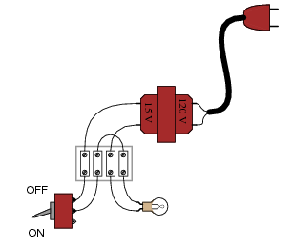

Electrical device

transformer

1. Determine the turns ratio: Ns : Np for the transformer. [2]
2. Some transformers can be up to 98% efficient. Describe 2 methods used in the construction of transformers to produce this efficiency. [2]

…………………………………………………………………………………………………….

…………………………………………………………………………………………………….

…………………………………………………………………………………………………….

…………………………………………………………………………………………………….

1. Suppose a power system were delivering AC power to a resistive load drawing 150 amps:

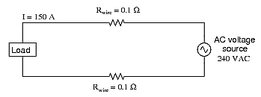

1. Calculate the load voltage and the load power dissipation. [3]
2. Now, suppose we were to use a pair of perfectly efficient 10:1 transformers to step the voltage up for transmission, and back down again for use at the load.

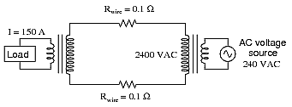

Calculate the load voltage, load power and the wasted power of this system. [5]